What is a Cross Tab Report?
A cross tab (crosstab) is basically a summary table that shows data in a matrix format.
Think of it like this:
 | Jan | Feb | Mar
Product A | 100 | 150 | 200
Product B | 80 | 120 | 160
Instead of listing rows like:
Product A - Jan - 100
Product A - Feb - 150
Product B - Jan - 80
Crosstab groups and summarizes data into rows & columns.

Why do we use Crosstabs?
Because raw data is messy.

Without Crosstab:
- Too many rows
- Hard to compare
- Not business-friendly

With Crosstab:
- Clean summary
- Easy comparison
- Perfect for reports
Used in:
- Sales reports
- Attendance reports
- Financial summaries
- Dashboards

Real Example (Your Use Case)
Let’s say you have this SQL data:
Product | Month | Sales
A | Jan | 100
A | Feb | 150
B | Jan | 80
We convert calculations into measure. e.g. (Here we convert sales into measure in crosstab) Note: Measure is the option in jasper crosstab

Goal Crosstab:
Product | Jan | Feb
A | 100 | 150
B | 80 | 0

Step 1: SQL Query (IMPORTANT)
In SQL Server, you DO NOT need to write complex pivot query
Just write a simple query like this:
First Query
SELECT
Product,Month,Sales
FROM SalesTable
We are using first Query for understand and second is from our database that is use for fetching the data of students (counting students) and semester and department wise

select u.unit_name,sem.description as semester,s.student_id
from edu_rgstr_student s
inner join edu_rgstr_semesters sem
on s.batch_id = sem.batch_id
inner join system_core_organization_hierarchy h
on h.org_hierarchy_id = s.department_id
inner join system_core_organization_unit u
on u.unit_id = h.sub_unit_id
group by u.unit_name,sem.description,s.student_id
Key idea:
Second Query
- JasperSoft will handle the crosstab
- SQL just provides raw data

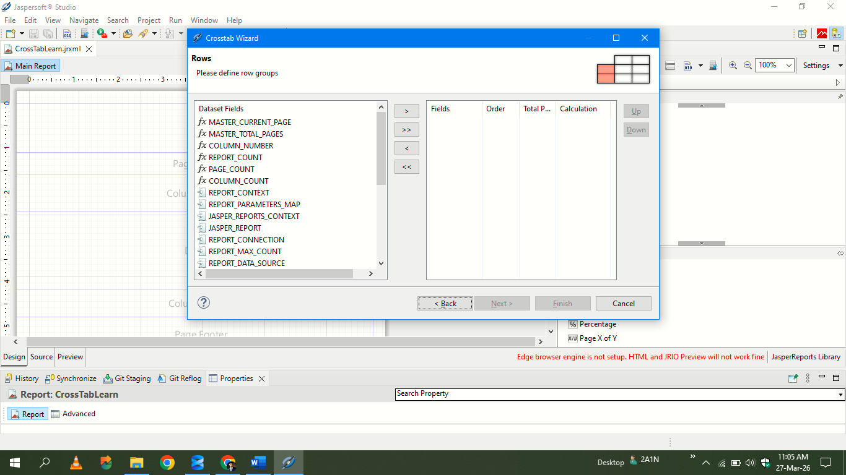
Step 2: Understanding Crosstab Structure
A Crosstab has 3 main parts:

1. Row Group
What goes on LEFT side
Example:
- Product
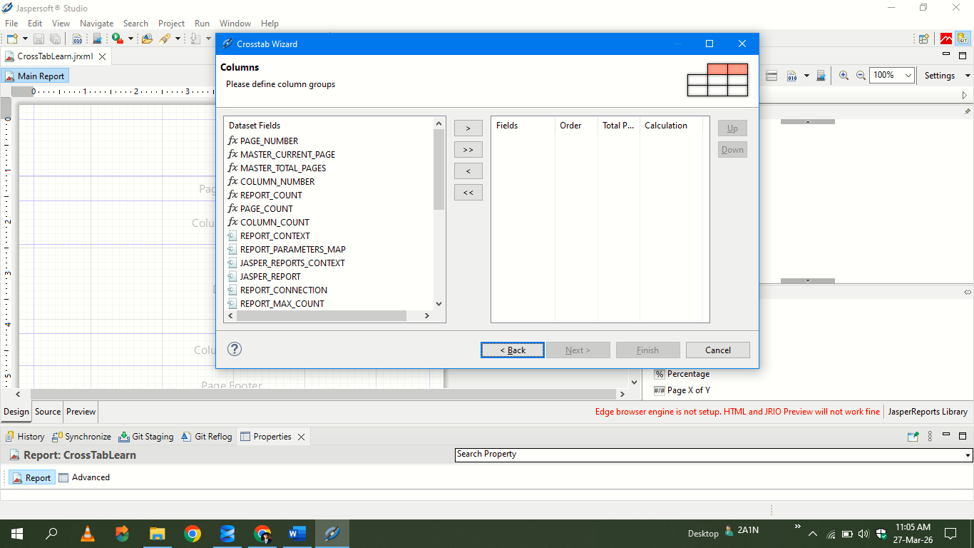

2. Column Group
What goes on TOP
Example:
- Month
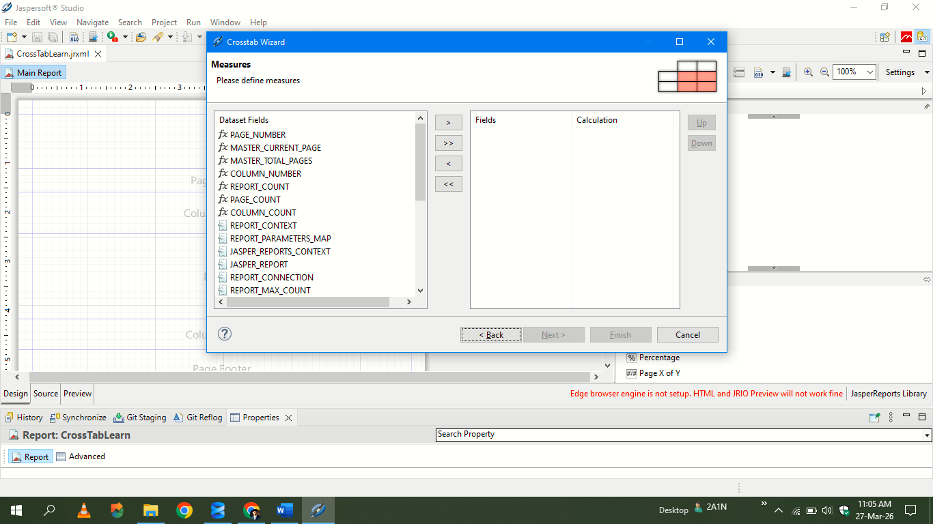

3. Measure

The VALUE inside table
Example:
- SUM(Sales)

Step 3: In JasperSoft Studio

Step-by-step:

1. Create Report
- Open JasperSoft Studio
- Create new report
- Connect to SQL Server

2. Add Query
Paste your SQL:
select u.unit_name,sem.description as semester, s.student_id from edu_rgstr_student s
inner join edu_rgstr_semesters sem
on s.batch_id = sem.batch_id
inner join system_core_organization_hierarchy h
on h.org_hierarchy_id = s.department_id
inner join system_core_organization_unit u
on u.unit_id = h.sub_unit_id
group by u.unit_name,sem.description,s.student_id
Click Read Fields
3. Add Crosstab
From palette:
- Drag Crosstab into report

4. Configure Crosstab

Row Group:
- Add: Semester

Column Group:
- Add: Department name (Unit_name)

Measure:
- Add: Student_id
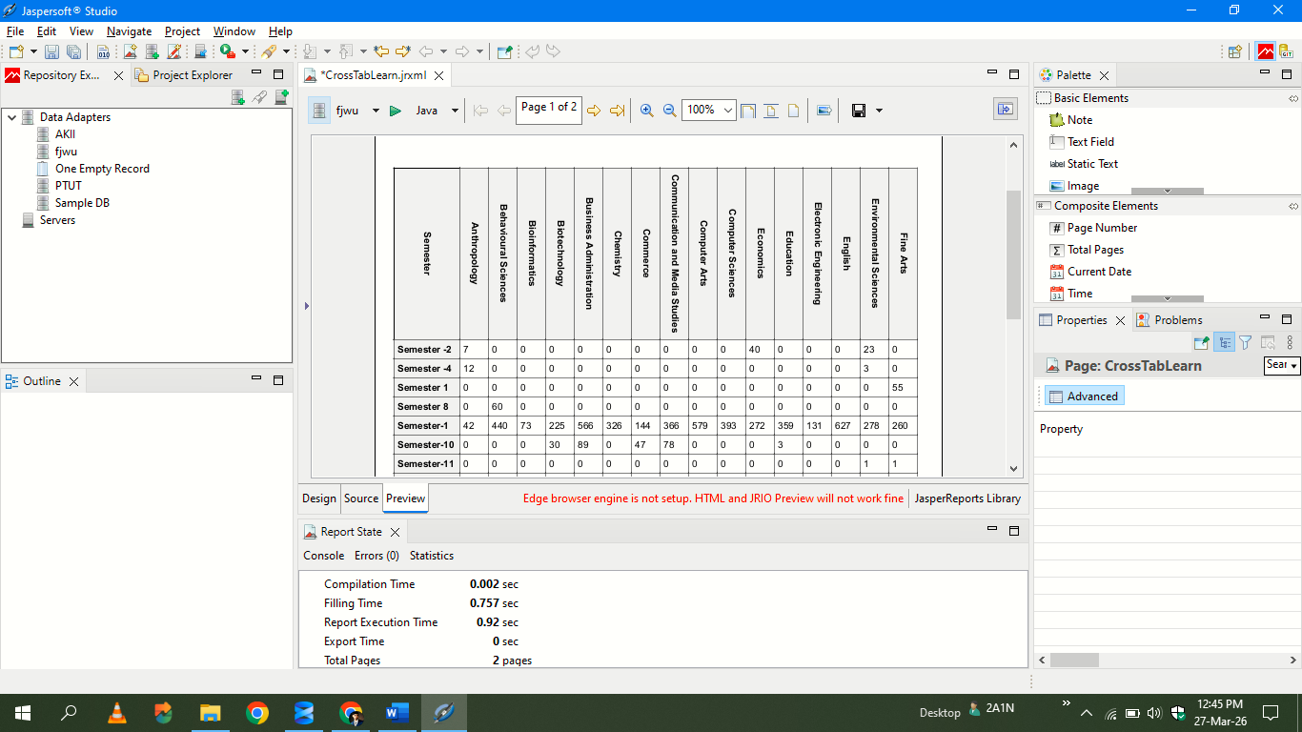
- Aggregation: Count

Final Output
Jasper will automatically generate:

Key Concepts (Don’t Skip This)

✔ Crosstab = Pivot Table (same idea)
If you've used Excel Pivot Table → SAME THING

✔ SQL vs Jasper Role
SQL | Jasper
Raw data | Formatting
Simple query | Crosstab logic

✔ Aggregation Functions
- SUM
- COUNT
- AVG

Common Mistakes
❌ Writing complex SQL PIVOT → Not needed
❌ Missing grouping fields → Crosstab breaks
❌ Using non-aggregated values in measure

Next Level (when you're ready)
After this, you can learn:
- Multiple row groups (Category → Product)
- Multiple measures (Sales, Quantity)
- Styling (colors, fonts)
- Dynamic columns

